**WP 1706**

**PUMICE HAND CLEANER**

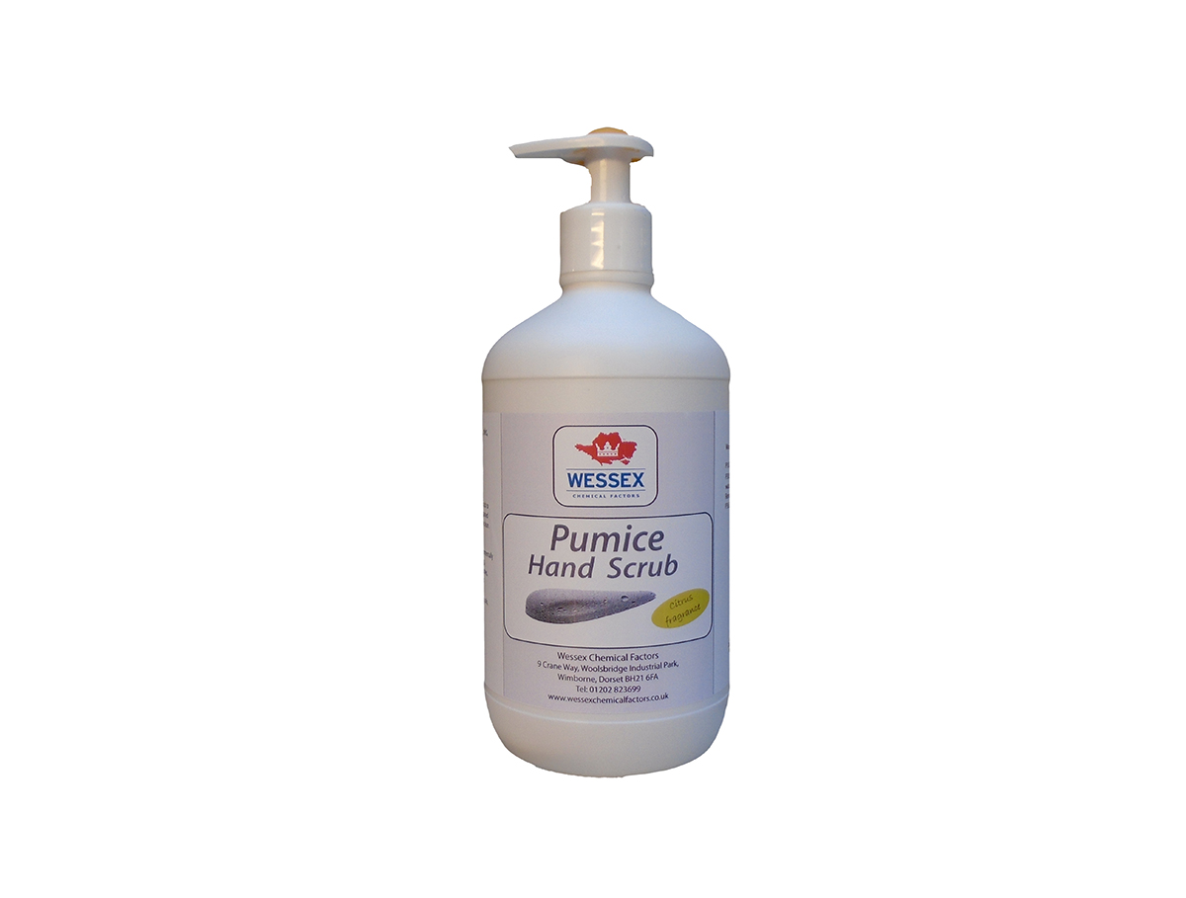

*Heavy duty environmentally friendly hand cleaner*

**PRODUCT SIZES**

* 250ml
* 500ml
* 5 litres

**BENEFITS**

* Removes tar bitumen and paint.
* Environmentally friendly formula.
* Fresh citrus fragrance.
* Natural pumice, no plastic beads.
* Can be used with or without water.

**DESCRIPTION**

Pumice hand scrub is a heavy duty environmentally friendly hand cleaner used in domestic and industrial environments.

It removes tar bitumen, resin, ink, grease, oils, paints and heavy industrial grime, resulting in clean and softened hands.

**INSTRUCTIONS FOR USE**

Apply a small amount of Pumice Hand Scrub to the hands, work into hands until ingrained dirt is removed. Rinse with water or wipe clean. Can be used on wet or dry hands.

**HEALTH & SAFETY**

**Hazard pictograms (CLP):**

**Hazard statements (CLP):**

To our knowledge, this product does not present any particular risk, provided it is handled in accordance with good occupational hygiene and safety practice.

**Precautionary statements (CLP):**

**Hazardous ingredients:**

**EUH210 – Safety Data Sheet available on request.**

**PHYSICAL PROPERTIES**

**Colour:** Yellow.

**Appearance:** Yellow liquid.

**Odour:** Lemon-like. Odour relevant to fragrance.

**Solubility:** No data available.

**Boiling point**: No data available.

**Flash point:** No data available.

**Flammability**: Not applicable.

**Density:** No data available.

**pH:** 6.5 – 7.5.



**Wessex Chemical Factors Ltd**

**9 Crane Way**

**Woolsbridge Industrial Park**

**Three Legged Cross**

**Wimborne**

**Dorset**

**BH21 6FA**

**United Kingdom**

**Tel: 01202 823699**

**Fax: 01202 813863**

**Email: info@wessexchemicalfactors.co.uk**

**Website:** [**www.wessexboatstore.co.uk**](http://www.wessexboatstore.co.uk)